1. Login to the GitHub page for bug tracking and upgrade requests:  
   <https://github.com/ResodynCorporation/RAMWare3_Bug_Tracker>
2. Click on the *Issues* tab

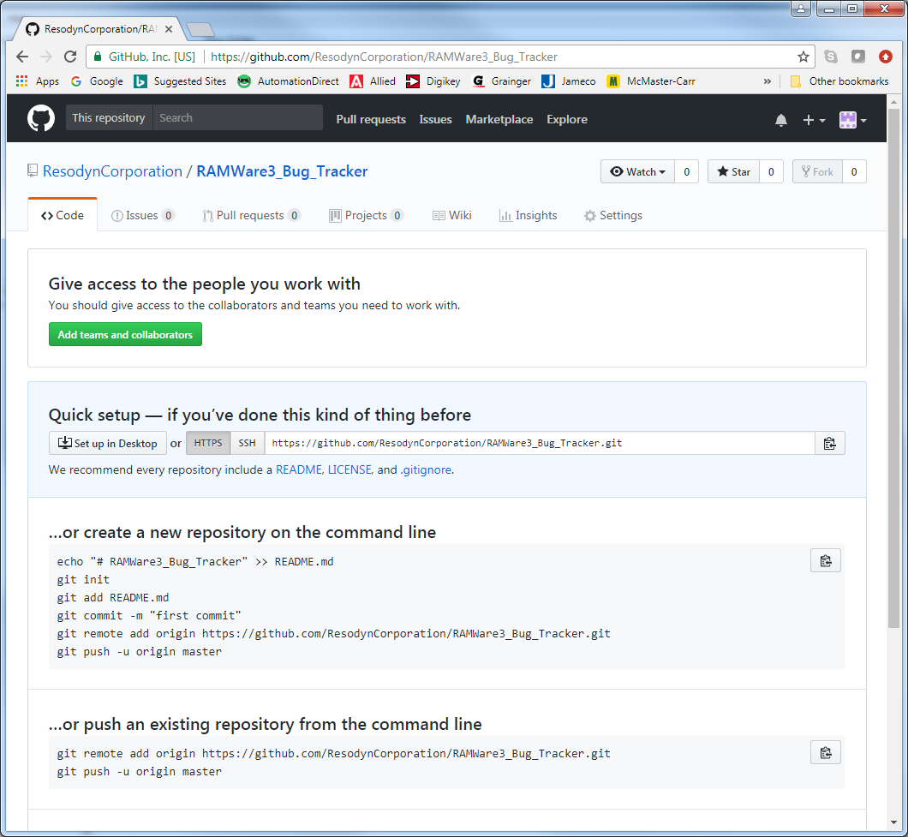

1. Click on the *New Issue* button

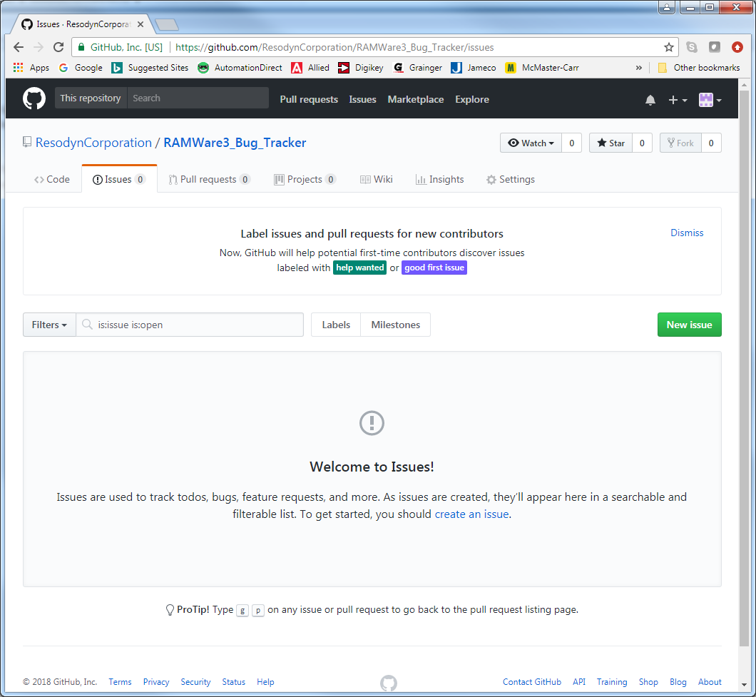

1. Type a helpful title and detailed message regarding the bug or requested feature. Please try to recall the steps that led to the issue, this is always helpful in resolving issues. Also, you can drag and drop screen shots here as well, which again, is very helpful! Hit the Submit new issue button when complete. Resodyn software developers will monitor this site for Beta tester feedback.

